**Project Name:**

# Customer profile at CardioGood Fitness.

**Context:**

The market research team at AdRight is assigned the task of identifying the typical customer profile for each treadmill product offered by CardioGood Fitness. The market research team decides to investigate whether there are differences across the product lines with respect to customer characteristics. The team decided to collect data on individuals who purchased a treadmill at a CardioGood Fitness retail store during the prior three months. The data are stored in the CardioGoodFitness.csv file.

**Source:**

<https://elp.northumbria.ac.uk/ultra/courses/_774007_1/outline/edit/document/_20473556_1?courseId=_774007_1&view=content&state=view>

**Variables**

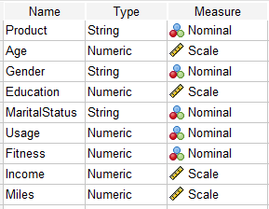The team identifies the following customer variables to study: product purchased, TM195, TM498, or TM798; gender; age, in years; education, in years; relationship status, single or partnered; annual household income ($); the average number of times the customer plans to use the treadmill each week; the average number of miles the customer expects to walk/run each week; and self-rated fitness on a 1-to-5 scale, where 1 is the poor shape, and 5 is excellent shape.

**Hypothesis**

**Ho:** There is no difference in assembly Education across the groups.

**H1:** At least one group’s assembly Education outperformed another.

**Comparing**

Product/Education

**Descriptive Statistics**

At least one group has a substantial departure from the normal distribution criteria. Because of that, instead of ANOVA we will use Kruskal - Wallis test.

|  |  |  |
| --- | --- | --- |
| Group 1 | Group 2 | Group 3 |
|  |  |  |

**Kruskal-Wallis Test**

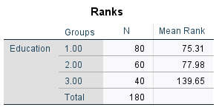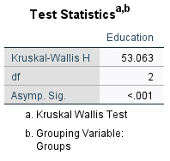

Since p<0.001 (<=0.05), this indicates that a significant difference has been detected among the groups.

|  |  |  |
| --- | --- | --- |
| **Run #1 --- Group 1: Group 2** | **Run #2 --- Group 1: Group 3\*\*** | **Run #3 --- Group 2: Group 3\*\*** |
|  |  |  |
| Since p=0.722 (<=0.05), this indicates that a significant difference has **NOT** been detected among the groups. | Since p<0.001 (<=0.05), this indicates that a significant difference has been detected among the groups. | Since p<0.001 (<=0.05), this indicates that a significant difference has been detected among the groups. |

**Hypothesis resolution**

REJECT

**Ho:** There is no difference in assembly Age across the groups.

ACCEPT

**H1:** At least one group’s assembly Age outperformed another.

**Documenting results**

**P< 0.05 ---- statistically significant difference.

The results showed a significant difference, indicating that two pair of groups had significantly different education levels.

**SPSS Screenshots**

